91 Advanced - Scripting & Extending Bforartists
Scripting & Extending Bforartists 1
General information 1
Getting Started - Manual links 2
Getting Started - External links 2
Extending Bforartists 2
Add-ons 2
Scripts 3
Saving your own scripts 3
File location 3
Installation 3
Add-ons 3
Searching 3
Enabling and Disabling 4
Installation of a 3rd party Add-on 5
File locations 5
Development guidelines 5
Scripting & Security 5
Scripts in Blend Files 5
Auto Execution 5
Manual Execution 6
Controlling Script Execution 6
Setting Defaults 6
Command Line 7

Scripting & Extending Bforartists

Note
Bforartists relies at the Blender Python API.

Python is an interpreted, interactive, object-oriented programming language. It incorporates modules, exceptions, dynamic typing, very high level dynamic data types, and classes. Python combines remarkable power with very clear syntax.
Python scripts are a powerful and versatile way to extend Bforartists functionality. Most areas of Bforartists can be scripted, including Animation, Rendering, Import and Export, Object Creation and the scripting of repetitive tasks.
To interact with Bforartists, scripts can make use of the tightly integrated API (Application Programming Interface).

General information
Links that are useful while writing scripts.
- http://www.python.org/ - Python.org - General information about Python.
- http://www.blender.org/documentation/250PythonDoc/ - Blender Python API - Official API documentation. Use this for referencing while writing scripts.
- http://www.blender.org/documentation/blender_python_api_2_72_release/info_quickstart.html - API introduction - A short introduction to get you started with the API. Contains examples.
- http://wiki.blender.org/index.php/Dev:2.5/Py/Scripts/Cookbook - CookBook - A section of handy code snippets (yet to be written)
Links that deal with distributing your scripts.
- http://wiki.blender.org/index.php/Dev:Py/Sharing - Sharing scripts - Information on how to share your scripts and get them included in the official Blender distribution.
- http://wiki.blender.org/index.php/Dev:2.5/Py/Scripts/Guidelines/Addons - Creating Add-ons - Add-ons are used to encapsulate and distribute scripts.
- https://projects.blender.org/projects/bf-extensions/ - Extensions project - Project to maintain a central repository of extensions to Blender.

Getting Started - Manual links
The following links take you from the basics to the more advanced concepts of Python scripting for Bforartists.
- Text Editor
- Python Console

Getting Started - External links
Here are external links containing a lot of good information to start learning how to write scripts for Bforartists.
- http://sites.google.com/site/satishgoda/blender/learningblender25/introduction-to-blender-python-api - Introductory tutorial by Satish Goda - Takes you from the beginning and teaches how to do basic API manipulations.
- http://www.youtube.com/watch?v=vmhU_whC6zw - Ira Krakow’s video tutorials - First video in a series of video tutorials.
- http://en.wikibooks.org/wiki/Blender_3D:_Blending_Into_Python/2.5_quickstart - Quickstart guide - A quickstart guide for people who already have some familiarity with Python and Blender.
- http://blenderartists.org/forum/showthread.php?t=164765 - Examples thread - A forum thread containing many short working script examples.
- http://cgcookie.com/blender/2011/08/26/introduction-to-scripting-with-python-in-blender/ - Introduction to Python - A one hour video tutorial introducing Python and the Blender API.

Extending Bforartists

Add-ons
Add-ons are scripts you can enable to gain extra functionality within Bforartists, they can be enabled from the user preferences.
Outside of the Bforartists executable, there are literally hundreds of add-ons written by many people:
- Officially supported add-ons are bundled with Bforartists.
- Other Testing add-ons are included in development builds but not official releases, many of them work reliably and are very useful but are not ensured to be stable for release.
For an overview of all add-ons is available in, see Scripts Catalog and Extensions tracker.
http://wiki.blender.org/index.php/Extensions:2.6/Py/Scripts
https://projects.blender.org/projects/bf-extensions/

Scripts
Apart from add-ons there are also scripts you can use to extend Bforartists functionality:
- Modules: Utility libraries for import into other scripts.
- Presets: Settings for Bforartists tools and key configurations.
- Startup: These files are imported when starting Bforartists. They define most of Bforartists UI, as well as some additional core operators.
- Custom scripts: In contrast to add-ons they are typically intended for one-time execution via the text editor

Saving your own scripts

File location
All scripts are loaded from the scripts folder of the local, system and user paths.
You can setup an additional search path for scripts in File Paths (User Preferences –> File Paths).

Installation
Add-ons are conveniently installed through Bforartists in the User Preferences –> Add-ons window. Click the Install from File... button and select the .py or .zip file.
To manually install scripts or add-ons place them in the add-ons, modules, presets or startup directory according to their type. See the description above.
You can also run scripts by loading them in the text editor window.

Add-ons

Add-on is the general term for a script that extends Bforartists functionality. They are found in the Add-ons tab of the User Preferences window. This tab allows to search, install, enable and disable Add-ons.

Searching
Bforartists comes with some useful Add-ons already, ready to be enabled, but you can also add your own, or any interesting ones you find on the web.
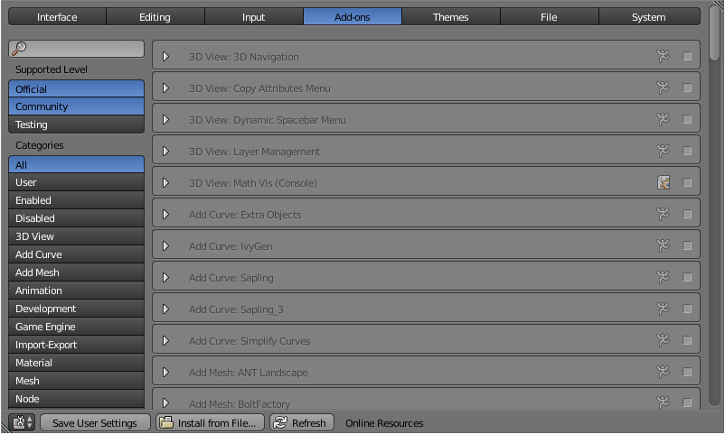
Add-ons tab in the User Preferences
The Scripts Catalog provides an index of Add-ons that are included with Bforartists as well as listing a number of external Add-ons.

Enabling and Disabling
Enable and disable and add-on by checking or unchecking the box on the right of the add-on you chose, as shown on the figure.

Enabling an Add-on
The add-on functionality should be immediately available. If the Add-on does not activate when enabled, check the Console window for any errors that may have occurred.
You can click the arrow at the left of the add-on box to see more information, such as where it is located, a description and a link to the documentation. Here you can also find a button to report a bug specific of this add-on.
Tip
Saving Add-on Preferences
If you want an Add-on to be enabled every time you start Bforartists, you will need to Save User Settings.

Installation of a 3rd party Add-on
For add-ons that you found on the web or your own to show on the list, you have to install them first by clicking Install from File... and providing a .zip or .py file.
Alternatively you can manually install an Add-on, which is useful when developing your own add-ons. Move or link the files to ../scripts/addons folder (where .. is the path to your Bforartists configuration folder).

File locations
For information on the location of Bforartists directories see: Configuration & Data Paths
You can also create a personal folder containing new add-ons and configure your files’ path in the File panel of the User Preferences. To create a personal script folder:
- Create an empty folder (i.e. ‘script_addon_2-7x’)
- Add one folder named ‘addons’. It has to named like this for Bforartists to recognize it.
- Put your new add-ons in this ‘addons’ folder.
- open the File panel of the User Preferences.
- Fill the Scripts entry with the path to your script folder (i.e. ‘script_addon_2-7x’).

Development guidelines
If you are a script developer, you may be interested in the Add-ons development guidelines

Scripting & Security

The ability to include Python scripts within blend files is valuable for advanced tasks such as rigging, automation and using the game-engine, however it poses a security risk since Python doesn’t restrict what a script can do.
Therefore, you should only run scripts from sources you know and trust.
Automatic execution is disabled by default, however some blend files need this to function properly.
When a blend file tries to execute a script and is not allowed, a message will appear in the header with the option to Reload Trusted or Ignore the message.

Scripts in Blend Files

Auto Execution
Here are the different ways blend files may automatically run scripts.
Registered Text-Blocks
A text block can have its Register option enabled which means it will load on start.
Animation Drivers
Python expressions can be used to Drive values and are often used in more advanced rigs and animations.
Game Engine Auto-Start
Scripts are often used for game logic, blend files can have Auto Start enabled with runs the game on load.

Manual Execution
There are other ways scripts in a blend file may execute that require user interaction (therefor will run even when auto-execution is off), but you should be aware that this is the case since it’s not necessarily obvious.
- Running a script in the text editor (ok, this is obvious!).
- Rendering with FreeStyle - FreeStyle uses scripts to control line styles
- Running the Game-Engine.

Controlling Script Execution
Bforartists provides a number of ways to control whether scripts from a blend file are allowed to automatically execute.
First of all, the file-selector has the option Trusted Source which you can use on a case-by-case basis to control auto-execution.
However you may forget to set this, or open a file without going through the file selector - so you can change the default (described next).

Setting Defaults
In the File section of the user-preferences there is the toggle Auto-Run Python Scripts.
This means the Trusted Source option in the file-selector will be enabled by default, and scripts can run when blend files are loaded without using the file selector.
Once enabled you have the option to exclude certain directories, a typical configuration would be to trust all paths except for the download directory.

Command Line
You may want to perform batch rendering or some other task from the command line - running Bforartists without an interface.
In this case the user-preferences are still used but you may want to override them.
- Enable with -y or --enable-autoexec
- Disable with -Y or --disable-autoexec
Example - rendering an animation in background mode, allowing drivers and other scripts to run:
Bforartists --background --enable-autoexec my_movie.blend --render-anim
Note
These command line arguments can be used to start a regular Bforartists instance and will still override the user-preferences.

